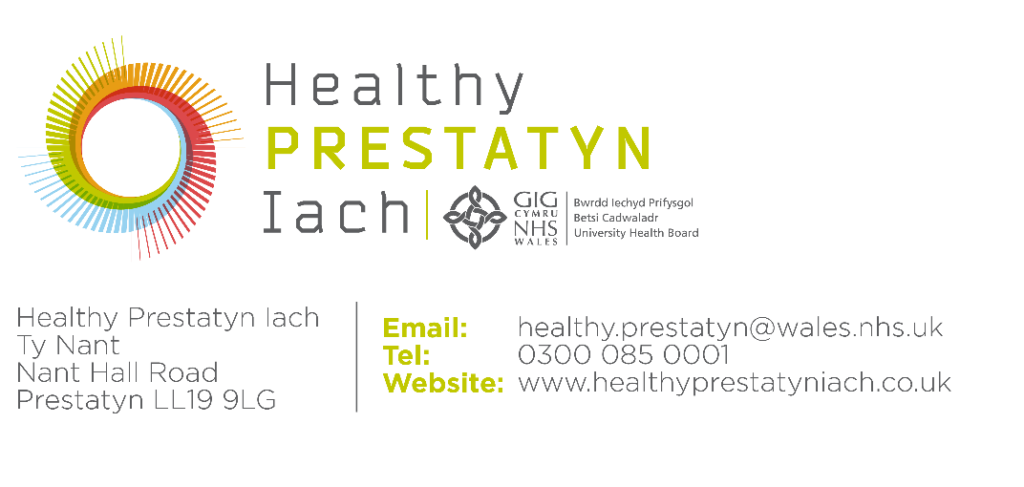

Householder

Dear Patient,

Please share the enclosed information with all members of your household who are patients of Healthy Prestatyn Iach.

We are writing to seek your views on proposed changes to the practice boundary for your GP Practice, Healthy Prestatyn Iach (HPI). We are currently undertaking a period of engagement to seek the views of patients, staff, local communities and stakeholders to inform the proposals.

The purpose of these proposed changes is to support the long-term sustainability of GP services across North Denbighshire. HPI currently operates across a very large geographical area and over multiple sites, which creates challenges in maintaining efficient and sustainable services. The proposals aim to ensure that:
- GP practice capacity is better aligned to local population needs;
- Patients continue to receive safe, high-quality and accessible care;
- Healthcare resources are used effectively and fairly across the area; and
- Local GP services remain sustainable for the future
If a change to the boundary is approved, patients who currently live outside the new boundary would have their care transferred to a GP Practice whose services cover their address. We recognise that changes to GP registration can be unsettling, and we want to reassure you that individual circumstances and patient needs will be carefully considered throughout the process.

Some frequently asked questions and responses, to provide some more detail on what the changes could mean for you are outlined below.
We are committed to ensuring patients are fully informed and supported throughout this process. In addition to this letter, during the engagement period, we will be holding drop-in sessions and engagement events where patients can:
• Ask questions about the proposals;
• Discuss any concerns directly with representatives from the project team;
• Learn more about potential alternative practices; and
• Share feedback before any decision is made.

Details of the dates, times and venues for these events will be shared shortly on the Healthy Prestatyn website and on social media.

You can also email any queries and comments to our mailbox, set up to gather views, the address is: bcu.denbighshireprimarycare@wales.nhs.uk

You can also contact us via telephone on 03000 851860. The phone line will be staffed between 10am and 2pm Monday – Friday. Outside these hours, you will be able to leave a voicemail message.

Scanning the QR code at the end of this letter will take you directly to a secure online feedback form, where you can quickly and easily share your comments, and suggestions about the proposals. Feedback on the proposal should be submitted before Friday 3rd July 2026.

Feedback gathered during the engagement period will be considered before the proposals are formally reviewed by a panel in July 2026.

Further information and support regarding registration arrangements would be provided should any changes be agreed.

Patients may also wish to provide feedback independently through Llais. Llais is an independent statutory body, set up by the Welsh Government to give the people of Wales more input into the planning and delivery of their health and social care services. The Llais contact details are:
Email: northwalesyourvoice@llaiscymru.org
Post: Llais Gogledd Cymru, 11 Llys Castan, Ffordd Y Parc, Parc Menai, Bangor, LL57 4FH
Telephone: 01248 679284 Website: www.llaiswales.org
Thank you for taking the time to consider these proposals. Your feedback is important and will help inform future decisions about GP services in your local area.
Yours faithfully,
Joe Lunn

Senior Practice Manager - Healthy Prestatyn Iach

Frequently Asked Questions (FAQs)

What is a Practice boundary?
All GP Practices operate within a designated GP boundary. GP Practices must register patients who live inside their practice boundary but have no legal requirement to register patients who live outside their boundary.

Why are these changes being proposed?
Healthy Prestatyn Iach (HPI) is currently one of the largest GP practices in North Wales in terms of both the geographical area it covers and the number of patients it serves. HPI was formed 10 years ago through the merger of three separate GP practices and is directly managed by Betsi Cadwaladr University Health Board (BCUHB).
Since the merger, the practice has continued to provide care across a very large area spanning parts of North Denbighshire and Flintshire. However, operating services across multiple sites and such a wide geographical footprint creates increasing operational and workforce pressures.
The proposed boundary changes are therefore being considered as part of a wider review of primary care services across the area. The aim is to ensure GP practice boundaries enable effective service provision and allow services to be delivered closer to home wherever possible.
Some neighbouring practices have said that taking on more patients could help strengthen their long-term sustainability and may allow them to offer a wider range of services in the future.
Overall, the proposals are intended to make it easier for patients to access care closer to home, better match practice populations with local service capacity, support long-term stability of GP practices, and make sure healthcare resources are used fairly across the area.

Has a final decision been made?
No. This is currently a proposal.
We are undertaking a formal period of engagement to gather feedback from patients, staff, community representatives and stakeholders to inform our decision. All feedback received during the engagement process will be carefully reviewed and will help inform the final recommendations.
Any proposals will also be subject to formal review processes within BCUHB before implementation.
Final decisions made by BCUHB regarding this process will be published on the practice website.

Will I have to change GP practice?
If the boundary changes are supported, patients living outside any revised HPI practice boundary would be transferred to an alternative local GP practice. This would happen automatically and affected patients would be informed of their new GP Practice in advance of the transfer.
At this stage, no immediate changes are taking place. If any changes are agreed, affected patients will receive clear information, support and guidance throughout the process.

When would the change happen?
If any changes were agreed, the decision should be taken by the end of July 2026. Any changes would then most likely happen between January and March 2027.

Why can’t I stay registered with HPI?
GP practices operate within agreed contractual practice boundaries. These boundaries help practices safely manage home visiting responsibilities, patient access and service delivery. If a practice boundary is formally changed, patients living outside the revised boundary may no longer be eligible to remain registered with that practice on a permanent basis.
The proposals are being considered to help create more sustainable and efficient GP services across the area while supporting patients to access care closer to home.

Will my care be disrupted?
Our aim is to minimise disruption as much as possible. If the proposals proceed, any patient transfers would happen gradually and in a carefully managed way, and support would be available for anyone requiring assistance.
All relevant clinical information will be transferred securely to patients’ new GP practices to support continuity of care. For patients with more complex needs, additional briefing notes will be added to their records to help ensure a safe and smooth transition. Established communication channels already exist between practices, and these will continue to be available should the new practice require any further information or clarification about a patient’s care needs. Existing medications, ongoing treatment plans and referrals would continue to be managed appropriately during any transition period.

What support will be available for vulnerable patients?
Patients with additional needs, including those receiving palliative care, individuals with complex health conditions, older adults, frail patients, patients with disabilities or mobility difficulties, and individuals requiring advanced support, will be considered carefully throughout the process.
Additional assistance and personalised support will be available where required to ensure vulnerable patients continue to receive safe and appropriate care. An option available is for patients with extremely challenging circumstances not to be moved from HPI.

How will this improve services?
The proposals aim to improve how GP services are organised across the area.
By aligning patients more closely with practices nearer to where they live, the changes may help improve access to local services, reduce travel demands for clinicians carrying out home visits, improve efficiency across practices, support workforce sustainability, and help neighbouring practices strengthen and grow their services.
The overall objective is to help ensure local GP services remain safe, sustainable and accessible for the long term.

How can I share my views?
Feedback gathered during the engagement period will be reviewed before any proposals are formally considered. You can provide feedback by attending one of the engagement or drop-in events, speaking directly with representatives from the project team, writing to the practice or Health Board, contacting Llais, and using the dedicated feedback channels as outlined in this letter.
Feedback can also be submitted by email to: bcu.denbighshireprimarycare@wales.nhs.uk
You can also contact us via telephone on 03000 851860. The phone line will be staffed between 10am and 2pm Monday – Friday. Outside these hours, you will be able to leave a voicemail message.

Will nearby GP practices be able to take additional patients?
BCUHB is working closely with neighbouring GP practices as part of this process.
Some local practices have expressed an interest in increasing their patient numbers as a way of strengthening the sustainability of their services and supporting future service development.
Any proposed changes would only proceed if there was confidence that practices could safely support additional patients while continuing to provide high-quality care.

Why is BCUHB involved in this process?
Healthy Prestatyn Iach is directly managed by Betsi Cadwaladr University Health Board (BCUHB), rather than operating as an independent contractor GP practice.
As part of its responsibility for planning and delivering sustainable healthcare services, BCUHB reviews how services are organised to ensure they continue to meet the needs of local communities both now and in the future.
The current engagement process forms part of that wider responsibility to ensure primary care services remain safe, effective and sustainable across North Wales.

What alternative GP practices may be available?
If the proposals are approved, patients who live in the affected addresses will be automatically transferred to the care of another GP Practice, close to where they live. If patients wish to change practice after this allocation they would contact the preferred practice and complete the registration process to join their patient list.

The following practices cover the areas affected:
GP Practice | Area covered
Park House Surgery  26 Nant Hall Rd, Prestatyn, LL19 9LN | Prestatyn, Rhyl and Ffynnongroyw
Clarence Medical Centre  West Kinmel Street, Rhyl, LL18 1DA | Prestatyn, Rhyl and Rhuddlan
Madryn House Surgery  6 Madryn Avenue, Rhyl, LL18 4RS | Rhyl and Rhuddlan
Kings House Surgery  Kings Avenue, Rhyl, LL18 1LT | Rhyl and Dyserth
Lakeside Medical Centre  Wellington Road, Rhyl, LL18 1LR | Rhyl and Rhuddlan
Pendre Surgery  Coleshill Street, Holywell, CH8 7UP | East of Prestatyn
Bodowen Surgery  Halkyn Street, Holywell, CH8 7GA | East of Prestatyn
Panton Surgery  Halkyn Road, Holywell, CH8 7SG | East of Prestatyn
Pennant Surgery  Off High Street, Holywell, CH8 7TR | East of Prestatyn
Pen Y Bont Surgery  The Roe, Saint Asaph LL17 0LU | Rhuddlan and Bodelwyddan
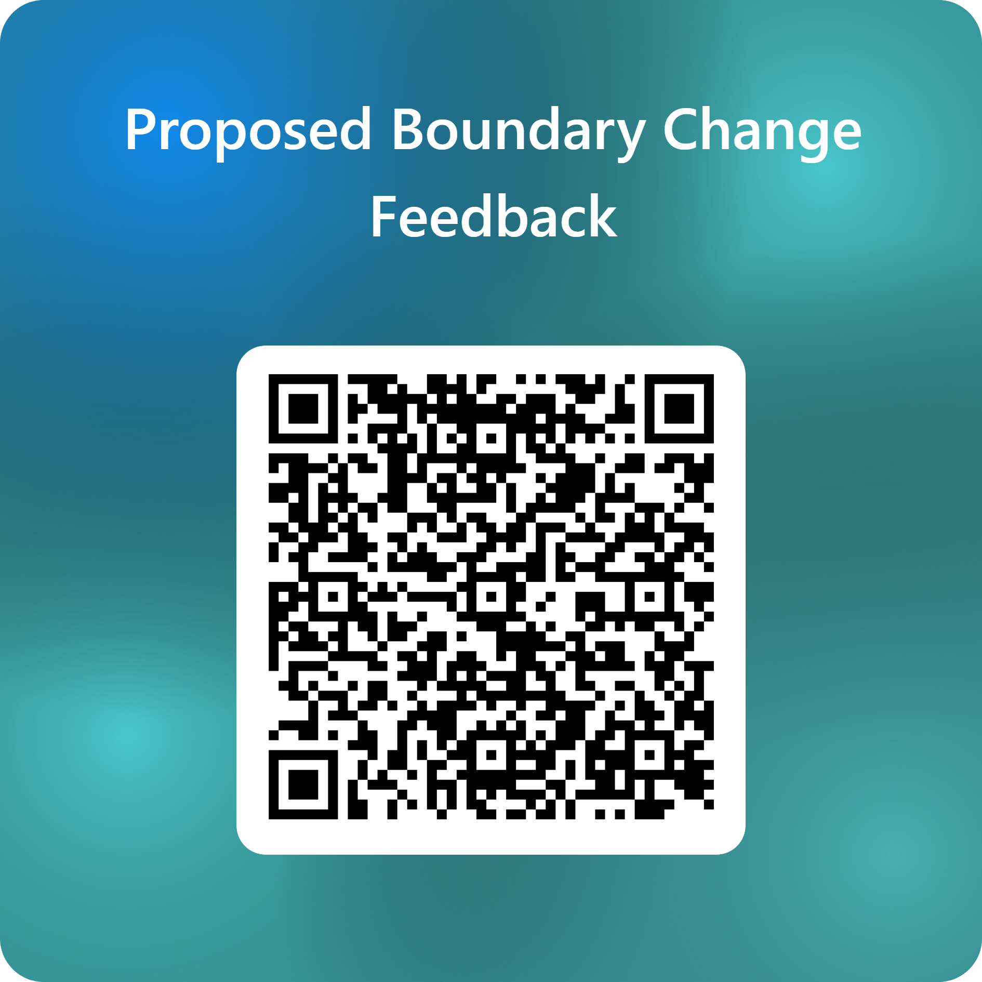

Annwyl Glaf,

Rhannwch y wybodaeth amgaeedig gyda holl aelodau eich aelwyd sy'n gleifion yn Healthy Prestatyn Iach.

Rydym yn ysgrifennu i ofyn am eich barn ar newidiadau arfaethedig i ffin eich Practis Meddyg Teulu, Healthy Prestatyn Iach (HPI). Ar hyn o bryd, rydym yn cynnal cyfnod o ymgysylltu i gasglu barn cleifion, staff, cymunedau lleol a rhanddeiliaid er mwyn llywio’r cynigion.

Diben y newidiadau arfaethedig yw cefnogi cynaliadwyedd hirdymor gwasanaethau Meddygon Teulu ar draws Gogledd Sir Ddinbych. Ar hyn o bryd, mae HPI yn gweithredu ar draws ardal ddaearyddol fawr iawn a thros sawl safle, sy'n creu heriau o ran cynnal gwasanaethau effeithlon a chynaliadwy. Nod y cynigion yw sicrhau bod:
- Capasiti'r Practis Meddyg Teulu wedi'i alinio'n well ag anghenion y boblogaeth leol;
- Cleifion yn dal i dderbyn gofal diogel, hygyrch ac o ansawdd uchel;
- Adnoddau gofal iechyd yn cael eu defnyddio mewn ffyrdd effeithiol a theg ar draws yr ardal; a
- Bod gwasanaethau meddygon teulu lleol yn dal i fod yn gynaliadwy ar gyfer y dyfodol.
Os cymeradwyir y newid i'r ffin, byddai gofal cleifion sy'n byw y tu allan i'r ffin newydd yn cael ei drosglwyddo i Bractis Meddyg Teulu sy'n gwasanaethu lleoliad eu cyfeiriad. Rydym yn cydnabod y gall newidiadau i gofrestriad â Meddygfa achosi pryder, a hoffem eich sicrhau y bydd amgylchiadau unigol ac anghenion cleifion yn cael eu hystyried yn ofalus drwy gydol y broses.

Rhai cwestiynau cyffredin ac ymatebion, i roi mwy o fanylion am yr hyn y gallai'r newidiadau ei olygu i chi wedi’u hamgau.
Rydym wedi ymrwymo i sicrhau bod cleifion yn cael yr holl wybodaeth berthnasol a chefnogaeth drwy gydol y broses hon. Yn ystod y cyfnod ymgysylltu, cynhelir cyfres o sesiynau galw heibio a digwyddiadau ymgysylltu lle gall cleifion:
• Ofyn cwestiynau am y cynigion;
• Trafod unrhyw bryderon yn uniongyrchol gyda chynrychiolwyr o dîm y prosiect;
• Dysgu mwy am arferion amgen posibl; a
• Rhannu adborth cyn gwneud unrhyw benderfyniad.

Bydd manylion y dyddiadau, yr amseroedd a'r lleoliadau ar gyfer y digwyddiadau hyn yn cael eu rhannu'n fuan ar wefan HPI ac ar y cyfryngau cymdeithasol. Gallwch e-bostio ein cyfrif e-bost, a sefydlwyd i gasglu barn, gydag unrhyw ymholiadau a sylwadau. Y cyfeiriad yw: bcu.denbighshireprimarycare@wales.nhs.uk

Gallwch hefyd gysylltu â ni dros y ffôn ar 03000 851860. Bydd staff yn gweithio ar y llinell ffôn rhwng 10am a 2pm o ddydd Llun i ddydd Gwener. Y tu allan i'r oriau hyn, gallwch adael neges ar y peiriant ateb.

Bydd sganio'r cod QR ar waelod y llythyr hwn yn mynd â chi'n uniongyrchol at ffurflen adborth ddiogel ar-lein, lle gallwch rannu eich sylwadau a'ch awgrymiadau am y cynigion yn gyflym ac yn hawdd. Bydd adborth a gesglir yn ystod y cyfnod ymgysylltu yn cael ei ystyried cyn i banel adolygu'r cynigion yn ffurfiol ym mis Gorffennaf 2026.

Byddai rhagor o wybodaeth a chymorth ynghylch trefniadau cofrestru yn cael eu darparu pe bai unrhyw newidiadau'n cael eu cytuno.

Efallai y bydd cleifion hefyd eisiau rhoi adborth yn annibynnol drwy Llais. Mae Llais yn gorff statudol annibynnol, a sefydlwyd gan Lywodraeth Cymru, i sicrhau llais cryfach i bobl Cymru ynghylch cynlluniau a darpariaeth eu gwasanaethau iechyd a gofal cymdeithasol. Manylion cyswllt Llais:
E-bost: northwalesyourvoice@llaiscymru.org
Post: Llais Gogledd Cymru, 11 Llys Castan, Ffordd Y Parc, Parc Menai, Bangor, LL57 4FH
Ffôn: 01248 679284 Gwefan: www.llaiswales.org
Diolch am roi o'ch amser i ystyried y cynigion hyn. Mae eich adborth yn bwysig a bydd yn ein helpu i wneud penderfyniadau am wasanaethau Meddyg Teulu yn eich ardal leol yn y dyfodol.
Yn gywir,
Joe Lunn Uwch Reolwr Practis Healthy Prestatyn Iach

Cwestiynau Cyffredin

Beth yw ffin Practis?
Mae pob Practis Meddyg Teulu yn gweithredu o fewn ffin Meddyg Teulu dynodedig. Rhaid i Bractisau Meddyg Teulu gofrestru cleifion sy'n byw o fewn eu ffin ond nid oes unrhyw ofyn cyfreithiol arnynt i gofrestru cleifion sy'n byw y tu allan i'w ffin.

Pam mae'r newidiadau hyn yn cael eu cynnig?
Ar hyn o bryd, Healthy Prestatyn Iach (HPI) yw un o'r Practisau Meddyg Teulu mwyaf yng Ngogledd Cymru o ran yr ardal ddaearyddol y mae'n ei gwasanaethu a nifer y cleifion y mae'n eu gwasanaethu. Ffurfiwyd HPI 10 mlynedd yn ôl trwy uno 3 practis meddyg teulu ac mae'n cael ei reoli'n uniongyrchol gan Fwrdd Iechyd Prifysgol Betsi Cadwaladr (BIPBC).
Ers yr uno, mae'r practis wedi parhau i ddarparu gofal ar draws ardal fawr iawn sy'n cwmpasu rhannau o Ogledd Sir Ddinbych a Sir y Fflint. Fodd bynnag, mae gweithredu gwasanaethau ar draws sawl safle ac ardal ddaearyddol mor fawr yn golygu bod pwysau cynyddol ar y gweithlu ac yn weithredol.
Felly, mae'r newidiadau arfaethedig i'r ffin yn cael eu hystyried fel rhan o adolygiad ehangach o wasanaethau gofal sylfaenol ar draws yr ardal. Y nod yw sicrhau bod ffiniau Practisau Meddyg Teulu yn galluogi darpariaeth gwasanaethau effeithiol ac yn caniatáu i wasanaethau gael eu darparu'n agosach at adref lle bynnag y bo modd.
Mae rhai practisau cyfagos wedi dweud y gallai derbyn mwy o gleifion helpu i gryfhau eu cynaliadwyedd hirdymor a gallai ganiatáu iddynt gynnig ystod ehangach o wasanaethau yn y dyfodol.
At ei gilydd, bwriad y cynigion yw ei gwneud hi'n haws i gleifion gael mynediad at ofal yn agosach at adref, paru poblogaethau practisau'n well â chapasiti gwasanaethau lleol, cefnogi sefydlogrwydd hirdymor Practisau Meddyg Teulu, a sicrhau bod adnoddau gofal iechyd yn cael eu defnyddio'n deg ar draws yr ardal.

A oes penderfyniad terfynol wedi'i wneud?
Na. Cynnig yw hwn ar hyn o bryd.
Rydym yn ymgymryd â chyfnod ffurfiol o ymgysylltu i gasglu adborth gan gleifion, staff, cynrychiolwyr cymunedol a rhanddeiliaid i lywio ein penderfyniad. Bydd yr holl adborth a dderbynnir yn ystod y broses ymgysylltu yn cael ei adolygu'n ofalus a bydd yn helpu i lywio'r argymhellion terfynol.
Bydd unrhyw gynigion hefyd yn destun prosesau adolygu ffurfiol o fewn BIPBC cyn eu gweithredu.

Bydd penderfyniadau terfynol a wneir gan BIPBC ynghylch y broses hon yn cael eu cyhoeddi ar wefan y practis.

A fydd yn rhaid i mi newid practis meddyg teulu?
Os cefnogir y newidiadau i'r ffin, byddai cleifion sy'n byw y tu allan i'r ffin practis ddiwygiedig yn cael eu trosglwyddo i Bractis Meddyg Teulu lleol arall. Byddai hyn yn digwydd yn awtomatig a byddai cleifion yr effeithir arnynt yn cael gwybod am eu Practis Meddyg Teulu newydd cyn iddynt gael eu trosglwyddo.
Ar hyn o bryd, nid oes unrhyw newidiadau uniongyrchol yn digwydd. Os cytunir ar unrhyw newidiadau, bydd cleifion yr effeithir arnynt yn derbyn gwybodaeth, cefnogaeth ac arweiniad clir drwy gydol y broses.

Pryd fyddai'r newid yn digwydd?
Os cytunir ar newidiadau, dylid derbyn y penderfyniad erbyn diwedd mis Gorffennaf 2026. Yna mae'n fwyaf tebygol y byddai unrhyw newidiadau'n digwydd rhwng Ionawr a Mawrth 2027.

Pam na allaf aros wedi cofrestru gyda HPI?
Mae Practisau Meddyg Teulu yn gweithredu o fewn ffiniau practis cytundebol y cytunwyd arnynt. Mae'r ffiniau hyn yn helpu practisau i reoli cyfrifoldebau o ran ymweld â chartrefi, mynediad i gleifion a darparu gwasanaethau yn ddiogel.
Os caiff ffin practis ei newid yn ffurfiol, efallai na fydd cleifion sy'n byw y tu allan i'r ffin ddiwygiedig yn gymwys i aros wedi'u cofrestru gyda'r practis hwnnw ar sail barhaol mwyach.
Mae'r cynigion yn cael eu hystyried i helpu i greu gwasanaethau meddyg teulu mwy cynaliadwy ac effeithlon ar draws yr ardal wrth gefnogi cleifion i gael mynediad at ofal yn agosach at adref.

A fydd tarfu ar fy nhrefniadau gofal?
Ein nod yw osgoi tarfu cymaint â phosibl.
Os bydd y cynigion yn mynd rhagddynt, byddai unrhyw drosglwyddiadau cleifion yn digwydd yn raddol ac mewn ffordd a reolir yn ofalus, a byddai cefnogaeth ar gael i unrhyw un sydd ei hangen.
Bydd yr holl wybodaeth glinigol berthnasol yn cael ei throsglwyddo'n ddiogel i bractisau meddyg teulu newydd cleifion i gefnogi parhad gofal. Ar gyfer cleifion ag anghenion mwy cymhleth, bydd nodiadau briffio ychwanegol yn cael eu hychwanegu at eu cofnodion i helpu i sicrhau trosglwyddiad diogel a di-dor. Mae sianeli cyfathrebu sefydledig eisoes yn bodoli rhwng practisau, a bydd y rhain yn dal i fod ar gael pe bai'r practis newydd angen unrhyw wybodaeth neu eglurhad pellach ynghylch anghenion gofal claf. Byddai meddyginiaethau presennol, cynlluniau triniaeth parhaus a chyfeiriadau yn dal i gael eu rheoli'n briodol yn ystod unrhyw gyfnod pontio.

Pa gymorth fydd ar gael i gleifion agored i niwed?
Bydd cleifion ag anghenion ychwanegol, gan gynnwys y rhai sy'n derbyn gofal lliniarol, unigolion â chyflyrau iechyd cymhleth, oedolion hŷn, cleifion eiddil, cleifion ag anableddau neu anawsterau symudedd, ac unigolion sydd angen cymorth estynedig, yn cael eu hystyried yn ofalus drwy gydol y broses.
Bydd cymorth ychwanegol a phersonol ar gael lle bo angen i sicrhau bod cleifion agored i niwed yn parhau i dderbyn gofal diogel a phriodol. Un opsiwn sydd ar gael yw i gleifion ag amgylchiadau heriol iawn beidio â chael eu symud o HPI.

Sut fydd hyn yn gwella gwasanaethau?
Nod y cynigion yw gwella sut mae gwasanaethau meddygon teulu wedi'u trefnu ar draws yr ardal.
Drwy alinio cleifion yn agosach â phractisau sy'n agosach at ble maen nhw'n byw, gall y newidiadau helpu i wella mynediad at wasanaethau lleol, lleihau gofynion teithio i glinigwyr sy'n cynnal ymweliadau cartref, gwella effeithlonrwydd ar draws practisau, cefnogi cynaliadwyedd y gweithlu, a helpu practisau cyfagos i gryfhau a datblygu eu gwasanaethau.
Y nod cyffredinol yw helpu i sicrhau bod gwasanaethau meddygon teulu lleol yn parhau i fod yn ddiogel, yn gynaliadwy ac yn hygyrch yn y tymor hir.

Sut alla i rannu fy safbwyntiau?
Bydd adborth a gesglir yn ystod y cyfnod ymgysylltu yn cael ei adolygu cyn i unrhyw gynigion gael eu hystyried yn ffurfiol. Gallwch rannu eich adborth drwy ddod i un o'r digwyddiadau galw heibio/ymgysylltu, siarad yn uniongyrchol â chynrychiolwyr o dîm y prosiect, ysgrifennu at y practis neu'r Bwrdd Iechyd, cysylltu â Llais, a defnyddio'r sianeli adborth pwrpasol fel yr amlinellir yn y llythyr hwn.
Gellir cyflwyno adborth drwy e-bost at: bcu.denbighshireprimarycare@wales.nhs.uk
Gallwch gysylltu â ni dros y ffôn ar 03000 851860. Bydd staff yn gweithio ar y llinell ffôn rhwng 10am a 2pm o ddydd Llun i ddydd Gwener. Y tu allan i'r oriau hyn, gallwch adael neges ar y peiriant ateb.

A fydd Practisau Meddyg Teulu cyfagos yn gallu derbyn cleifion ychwanegol?
Mae BIPBC yn gweithio'n agos gyda phractisau Meddyg Teulu cyfagos fel rhan o'r broses hon.
Mae rhai practisau lleol wedi mynegi diddordeb mewn cynyddu nifer eu cleifion fel ffordd o gryfhau cynaliadwyedd eu gwasanaethau a chefnogi datblygiad gwasanaethau yn y dyfodol.
Dim ond os oes hyder y gallai practisau gynnal gofal cleifion ychwanegol yn ddiogel gan barhau i ddarparu gofal o ansawdd uchel y byddai unrhyw newidiadau arfaethedig yn mynd rhagddynt.

Pam mae BIPBC yn rhan o'r broses hon?
Mae Healthy Prestatyn Iach yn cael ei reoli'n uniongyrchol gan Fwrdd Iechyd Prifysgol Betsi Cadwaladr (BIPBC), yn hytrach na gweithredu fel Practis Meddyg Teulu sy'n gontractwr annibynnol.
Fel rhan o'i gyfrifoldeb am gynllunio gwasanaethau gofal iechyd cynaliadwy a'u darparu, mae BIPBC yn adolygu sut mae gwasanaethau'n cael eu trefnu i sicrhau eu bod yn parhau i ddiwallu anghenion cymunedau lleol nawr ac yn y dyfodol.
Mae'r broses ymgysylltu bresennol yn rhan o'r cyfrifoldeb ehangach hwnnw i sicrhau bod gwasanaethau gofal sylfaenol yn dal i fod yn ddiogel, yn effeithiol ac yn gynaliadwy ledled Gogledd Cymru.

Pa Bractisau Meddyg Teulu amgen a allai fod ar gael?
Os caiff y cynigion eu cymeradwyo, bydd cleifion sy'n byw yn y cyfeiriadau yr effeithir arnynt yn cael eu trosglwyddo'n awtomatig i ofal Practis Meddyg Teulu arall, yn agos at ble maent yn byw. Os yw cleifion yn dymuno newid practis ar ôl eu dyrannu, gallant gysylltu â'r practis dewisol a chwblhau'r broses gofrestru i ymuno â'u rhestr cleifion.
Y practisau canlynol yn cwmpasu’r ardaloedd yr effeithir arnynt:

Practisiau Meddyg Teulu | Ardaloedd a gwmpesir
Meddygfa Park House  26 Ffordd Llys Nant, Prestatyn, LL19 9LN | Prestatyn, y Rhyl a Ffynnongroyw
Canolfan Feddygol Clarence  West Kinmel Street, Y Rhyl, LL18 1DA | Prestatyn, y Rhyl a Rhuddlan
Meddygfa Madryn House  6 Madryn Avenue, Y Rhyl, LL18 4RS | Rhyl a Rhuddlan
Meddygfa Kings House  Kings Avenue, Y Rhyl, LL18 1LT | Rhyl a Dyserth
Canolfan Feddygol Lakeside  Wellington Road, Y Rhyl, LL18 1LR | Rhyl a Rhuddlan
Meddygfa Pendre  Stryd Coleshill, Treffynnon, CH8 7UP | Ardaloedd i'r dwyrain o Prestatyn
Meddygfa Bodowen  Heol Helygain, Treffynnon, CH8 7GA | Ardaloedd i'r dwyrain o Prestatyn
Meddygfa Panton  Ffordd Helygain, Treffynnon | Ardaloedd i'r dwyrain o Prestatyn
Meddygfa Pennant  Oddi ar Heol Fawr, Treffynnon, CH8 7TR | Ardaloedd i'r dwyrain o Prestatyn
Meddygfa Pen y Bont  Y Roe, Llanelwy LL17 0LU | Rhuddlan a Bodelwyddan

